Our Ref: _______________ Your Ref: ________________________ Date: __________________

Baptist Church

Baale Yaku Site Area, P. O. Box 644,

Ogbomoso, Oyo State. Tel. 07052425407

Email: [newsprinbaptistchurch@gmail.com](mailto:newsprinbaptistchurch@gmail.com)

Website: newspringbc.comze.com

NEW SPRING

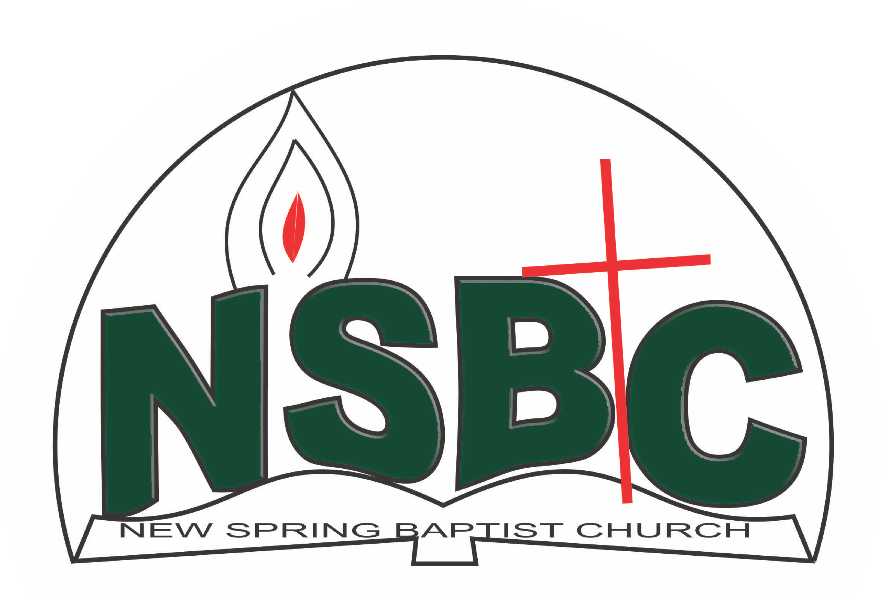

2 January 2022

Dear Dn. Omo Olupona,

Nomination to Serve as an Officer and Worker in the Church in 2022.

Calvary greetings in the precious name of our Lord and Saviour Jesus Christ. It is our pleasure to inform you that at the Church-in-Conference held on 19 December, 2021 the Church ratified your nomination to serve in the following areas between January 1 and December 31, 2022:

1. Sunday School teacher
2. Superintendent, Discipleship Training Programme
3. Chairman, Building Committee
4. Member, Counselling & Follow-up Committee under the chairmanship of Dcs. Christiana Oketoobo
5. Member, Health Committee under the chairmanship of Mrs. Nia Olupona
6. Member, Mission & Evangelism Committee under the leadership of Dn. Ayinde Ezekiel
7. Chairman, Waiting & Expectant Couple Committee
8. Member, Elders’ Council
9. Member, Personnel Committee under the leadership of Mrs. Mobolape Adelakun
10. Member, Church Council

Please refer to the table below for the key functions of each of these roles. Details can be found in the Church constitution. You are strongly encouraged to become familiar with the tasks as stated in the document. There will be an orientation of the Church workers on January 22, 2022 at 8:30 a.m. on the church premises. Please ensure you participate in this training.

“Now it is required that those who have been given a trust must prove faithful. I Corinthians 4:2”. May God find you faithful in the task He has assigned to you.

| Domain | Key function of Office, Department or Committee |
| --- | --- |
| Sunday School teacher | To provide support to the Church Pastor in the teaching ministry of the Church to ensure that members and regular worshippers are well grounded in the Scriptures. |
| Superintendent, Discipleship Training Programme | To provide support to the Church Pastor in the ministry of the Church to ensure that members and regular worshippers are well equipped for every good work. |
| Building Committee | Responsible for the implementation of the benevolence policy of the Church |
| Member, Counselors & Follow-up | To help decision makers understand and follow through on their decisions |
| Member, Health Committee | Support the Church Pastor in providing professional guidance to the Church in health related matters of the Church members |
| Member, Mission & Evangelism Committee | Responsible for the mobilization of Church members for soul winning activities. |
| Waiting & Expectant Couple Committee | To provide encouragement, advice and spiritual support for waiting and expecting couples |
| Member, Elders’ Forum | To intervene and help members who may have grudges against others resolve matters as quickly as possible |
| Member, Personnel Committee | To assist the Church in matters relating to personnel administration |
| Church Council | The Church Council is the governing body of the Church whose membership, under the leadership of the Holy Spirit, holds one another mutually accountable with respect and love and sees to the smooth running of the Church. |

Thank you for accepting to serve in this Church.

Yours in His service

Olusayo Okediji Blessed Agboola

Church Secretary                                                                                     Chairman, Nominating Committee